Hotel Booking Application screenshots

Home Page

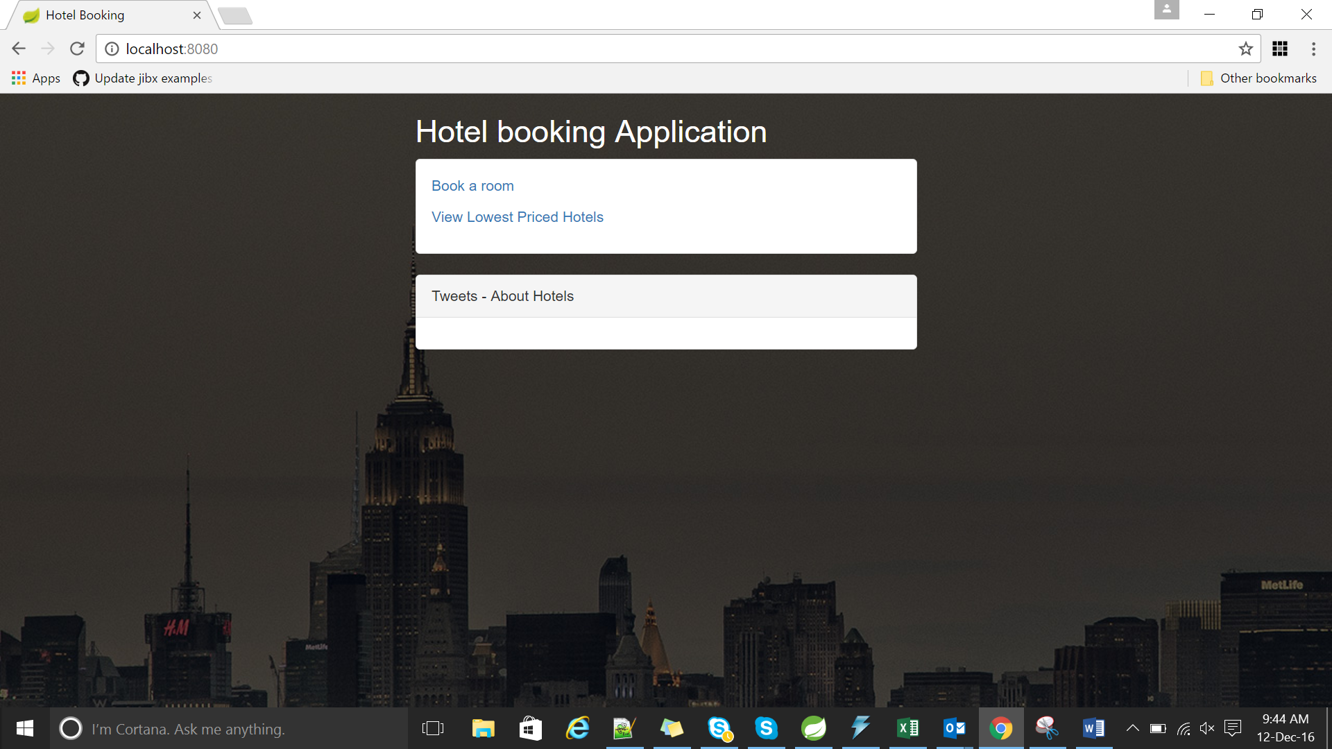

After loading the twitter data (takes some seconds to load the data)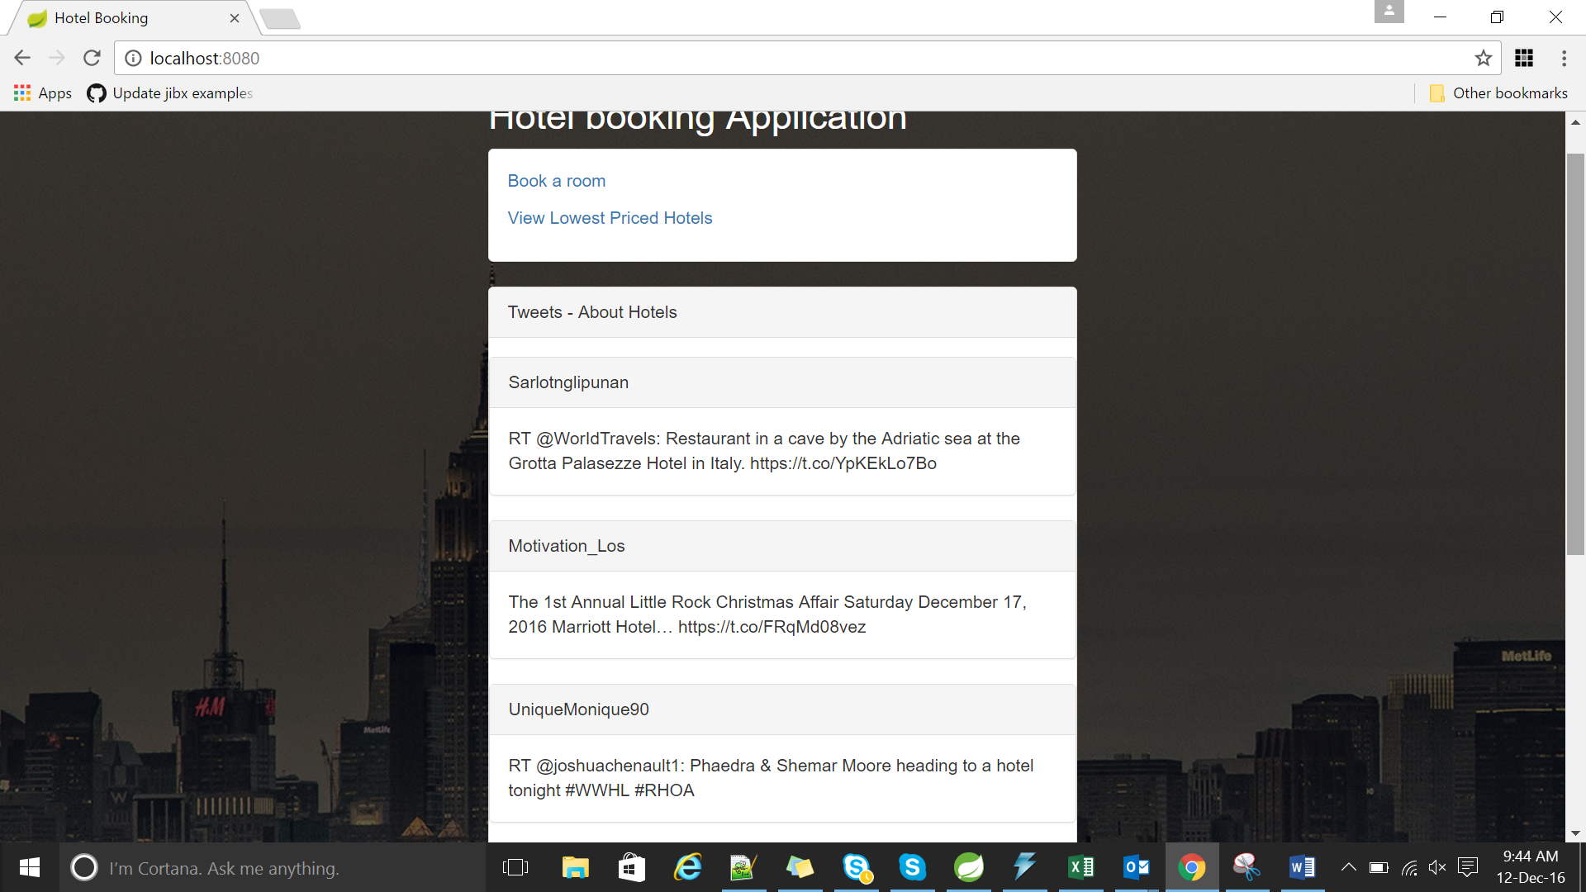

After clicking the Book a room link

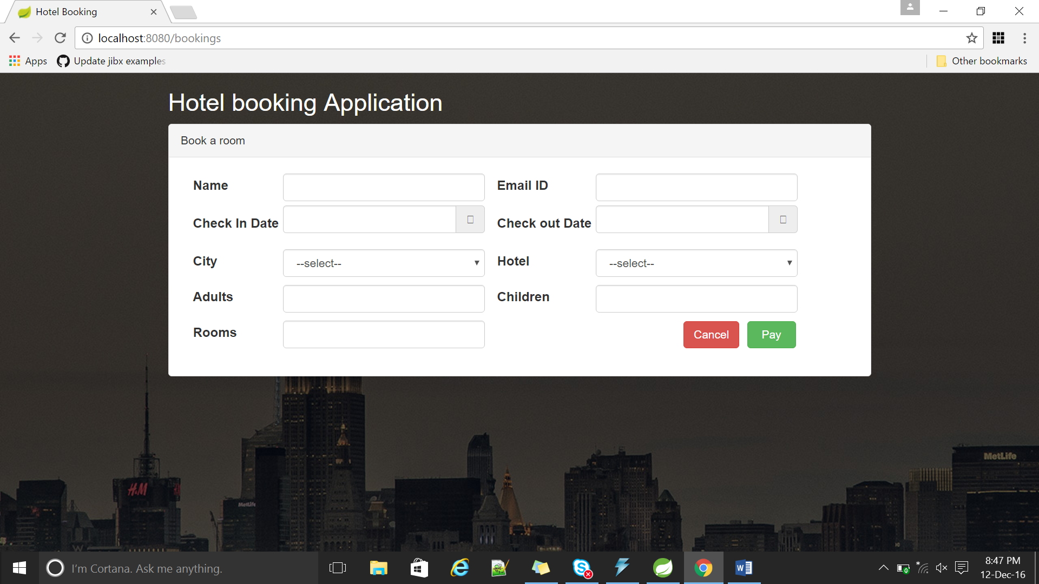

Check out date calendar enabled feature dates validation

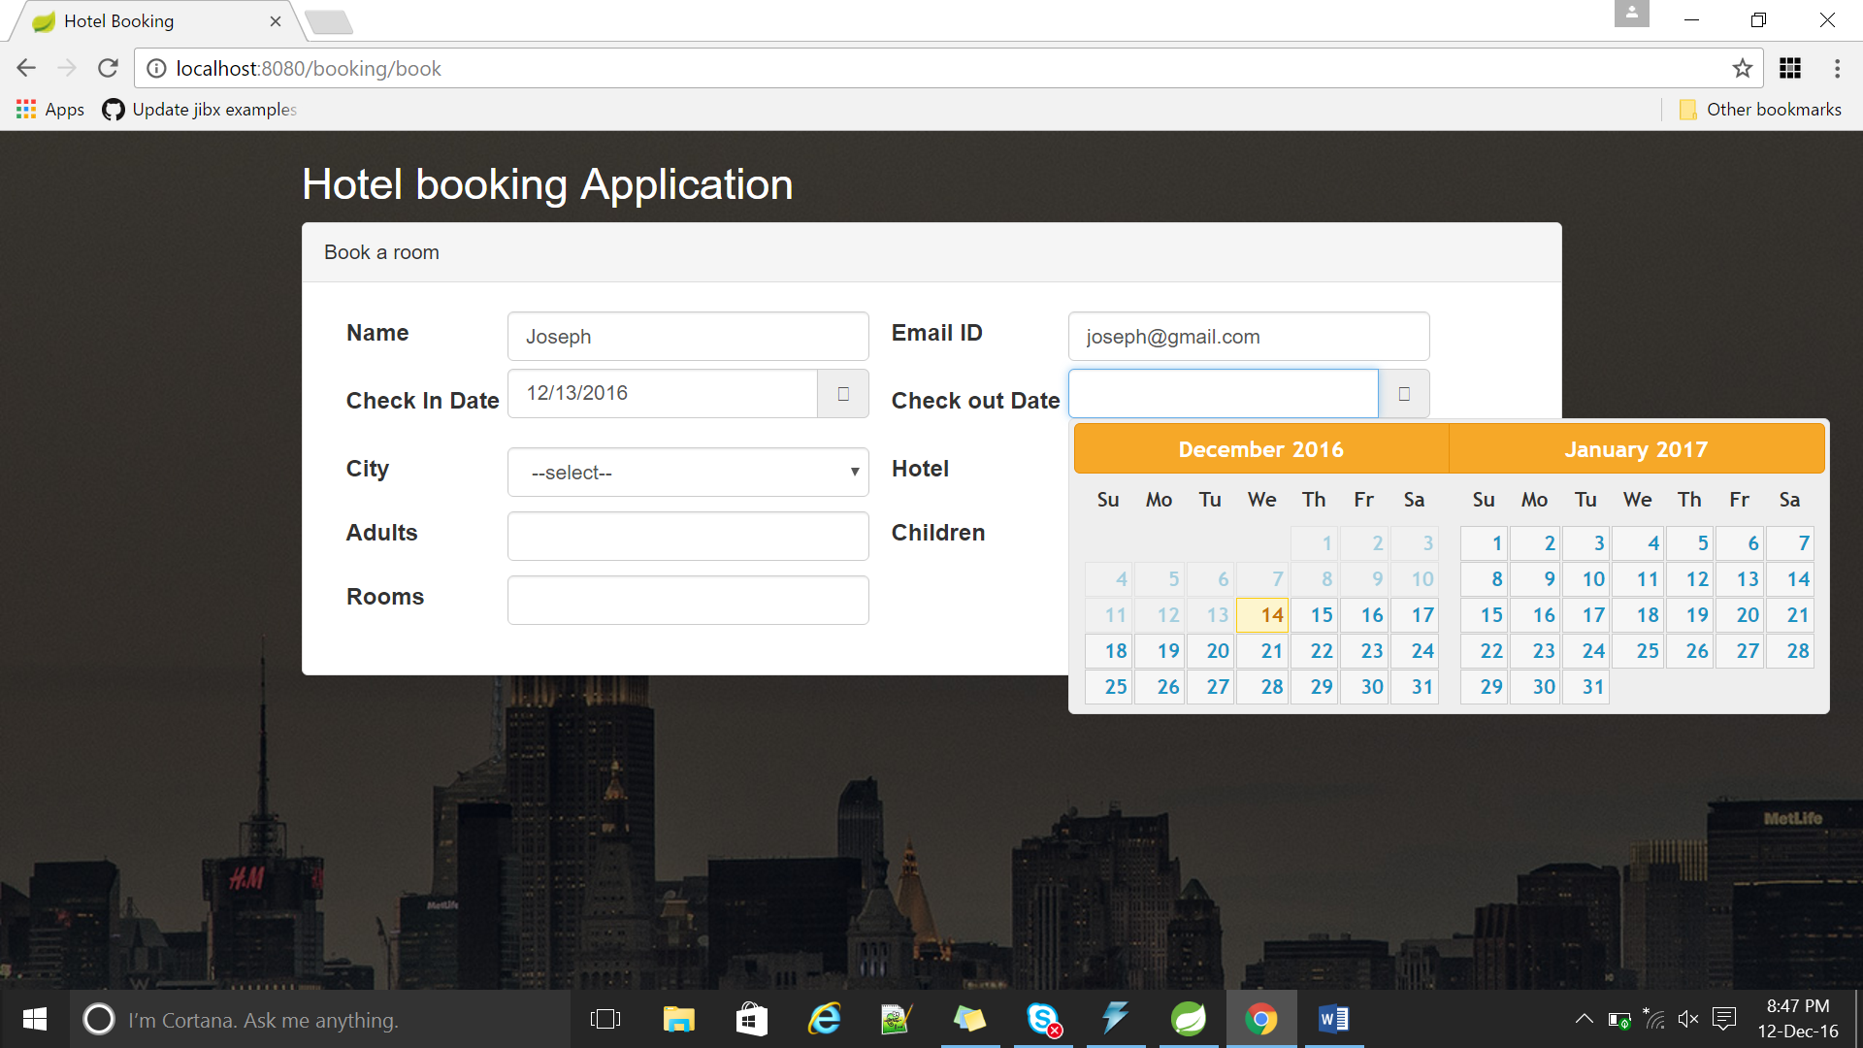

After Booking room (clicking Pay button)

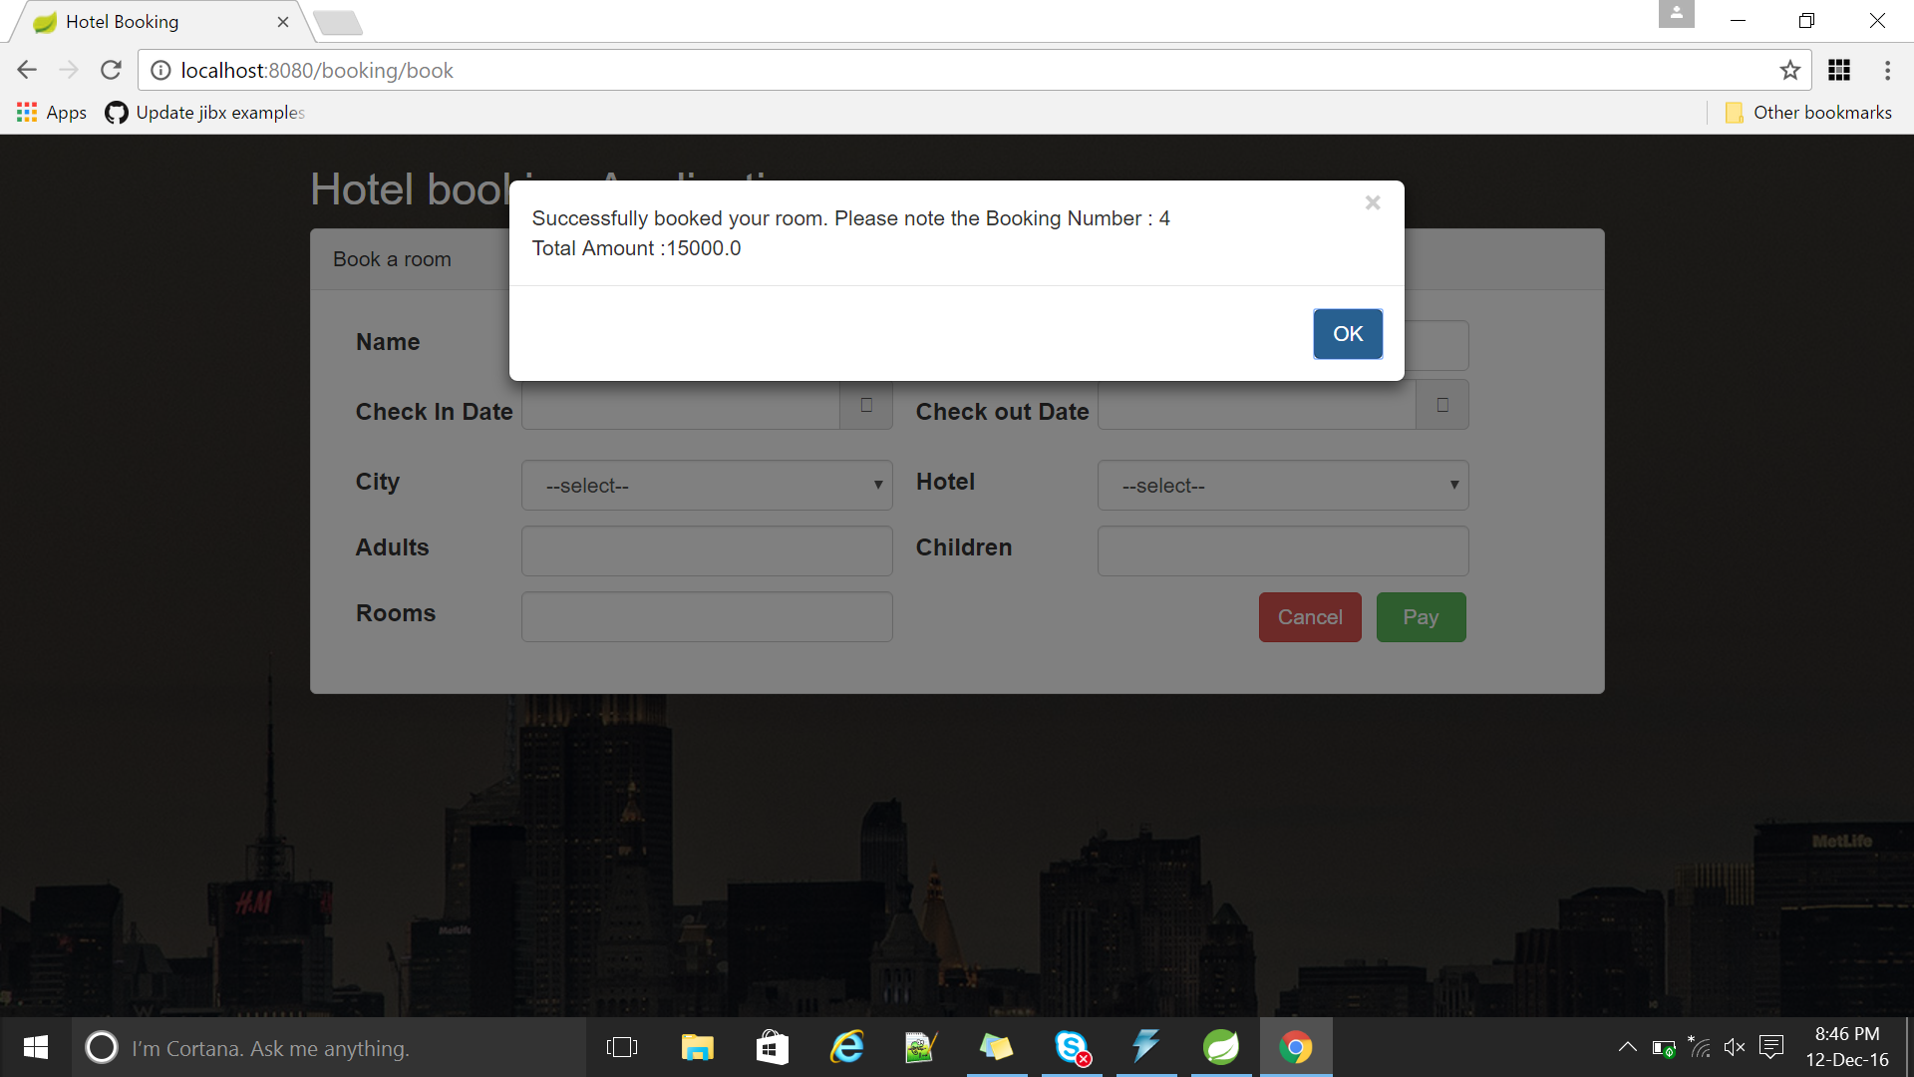

Click cancel button to home page

After clicking [View Lowest Priced Hotels](http://localhost:8080/viewrooms) link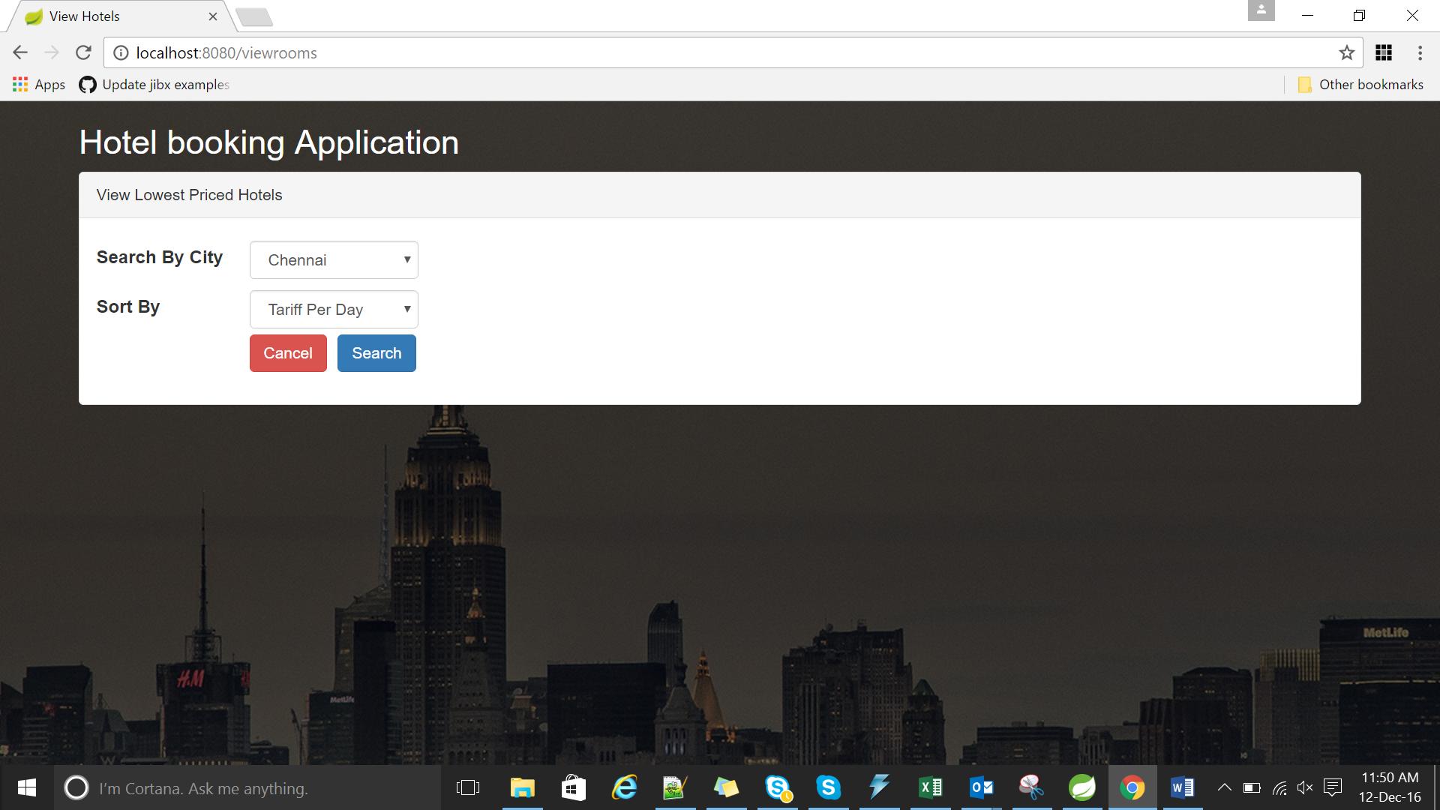

After clicking Search button

